McCLOSKEY DUCKS
MIXED MEDIA WEARABLE ART ACTIVITY

Inspired by the books:

Make Way for Ducklings and Love Is
Grades: Pre K- 2nd

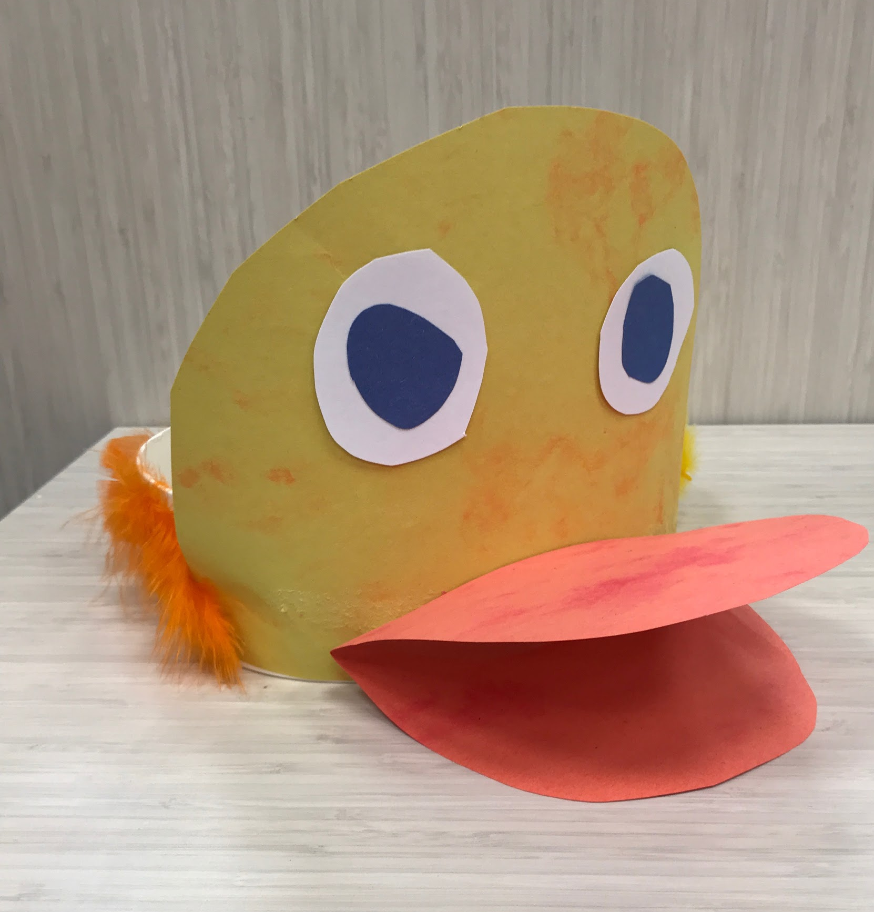
Finished Duck Hat

OBJECTIVES/OUTCOMES
- Students will create a wearable piece of art using mixed media.
- Students will learn that ducks are hatched from eggs.
- Students will learn the meaning of mallard and chick.

DESCRIPTION OF ACTIVITY/CONCEPT
Students will construct a duck face out of construction paper pieces. The face will be glued to a head band which the students may decorate with feathers. Students may then wear their hats and pretend to be a duck.

MATERIALS
Construction paper (orange, yellow, white, and blue), strip of white matte board, feathers (orange and yellow), glue sticks, staples, and tape.

VOCABULARY
Mallard – a common wild duck of the northern hemisphere. The males of which have a green head and white-ringed neck and is the source of the domestic ducks.
Chick – a young bird, especially one newly hatched.

PROCEDURE
1. Precut yellow half circle (duck head), blue and white circle (eyes), and orange oval (beak) out of construction paper.
2. Students glue head to the middle of the white matte board strip using a glue stick.
3. Fold beak twice leaving approximately a half inch strip in the center of the oval so that the mouth may open and close.
4. Students use a glue stick to glue along that half inch strip and attach the beak to the hat.
5. Students glue the white and blue circles onto the hat for eyes.
6. Students can then decorate the white headband using their glue stick and feathers.
7. Help adjust the headband so that it fits on the student's heads and staple the band together to finish your duck hat.

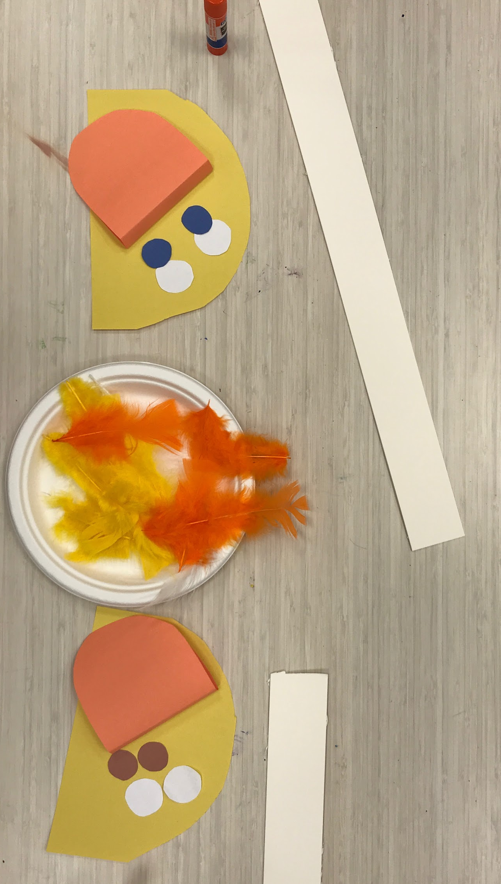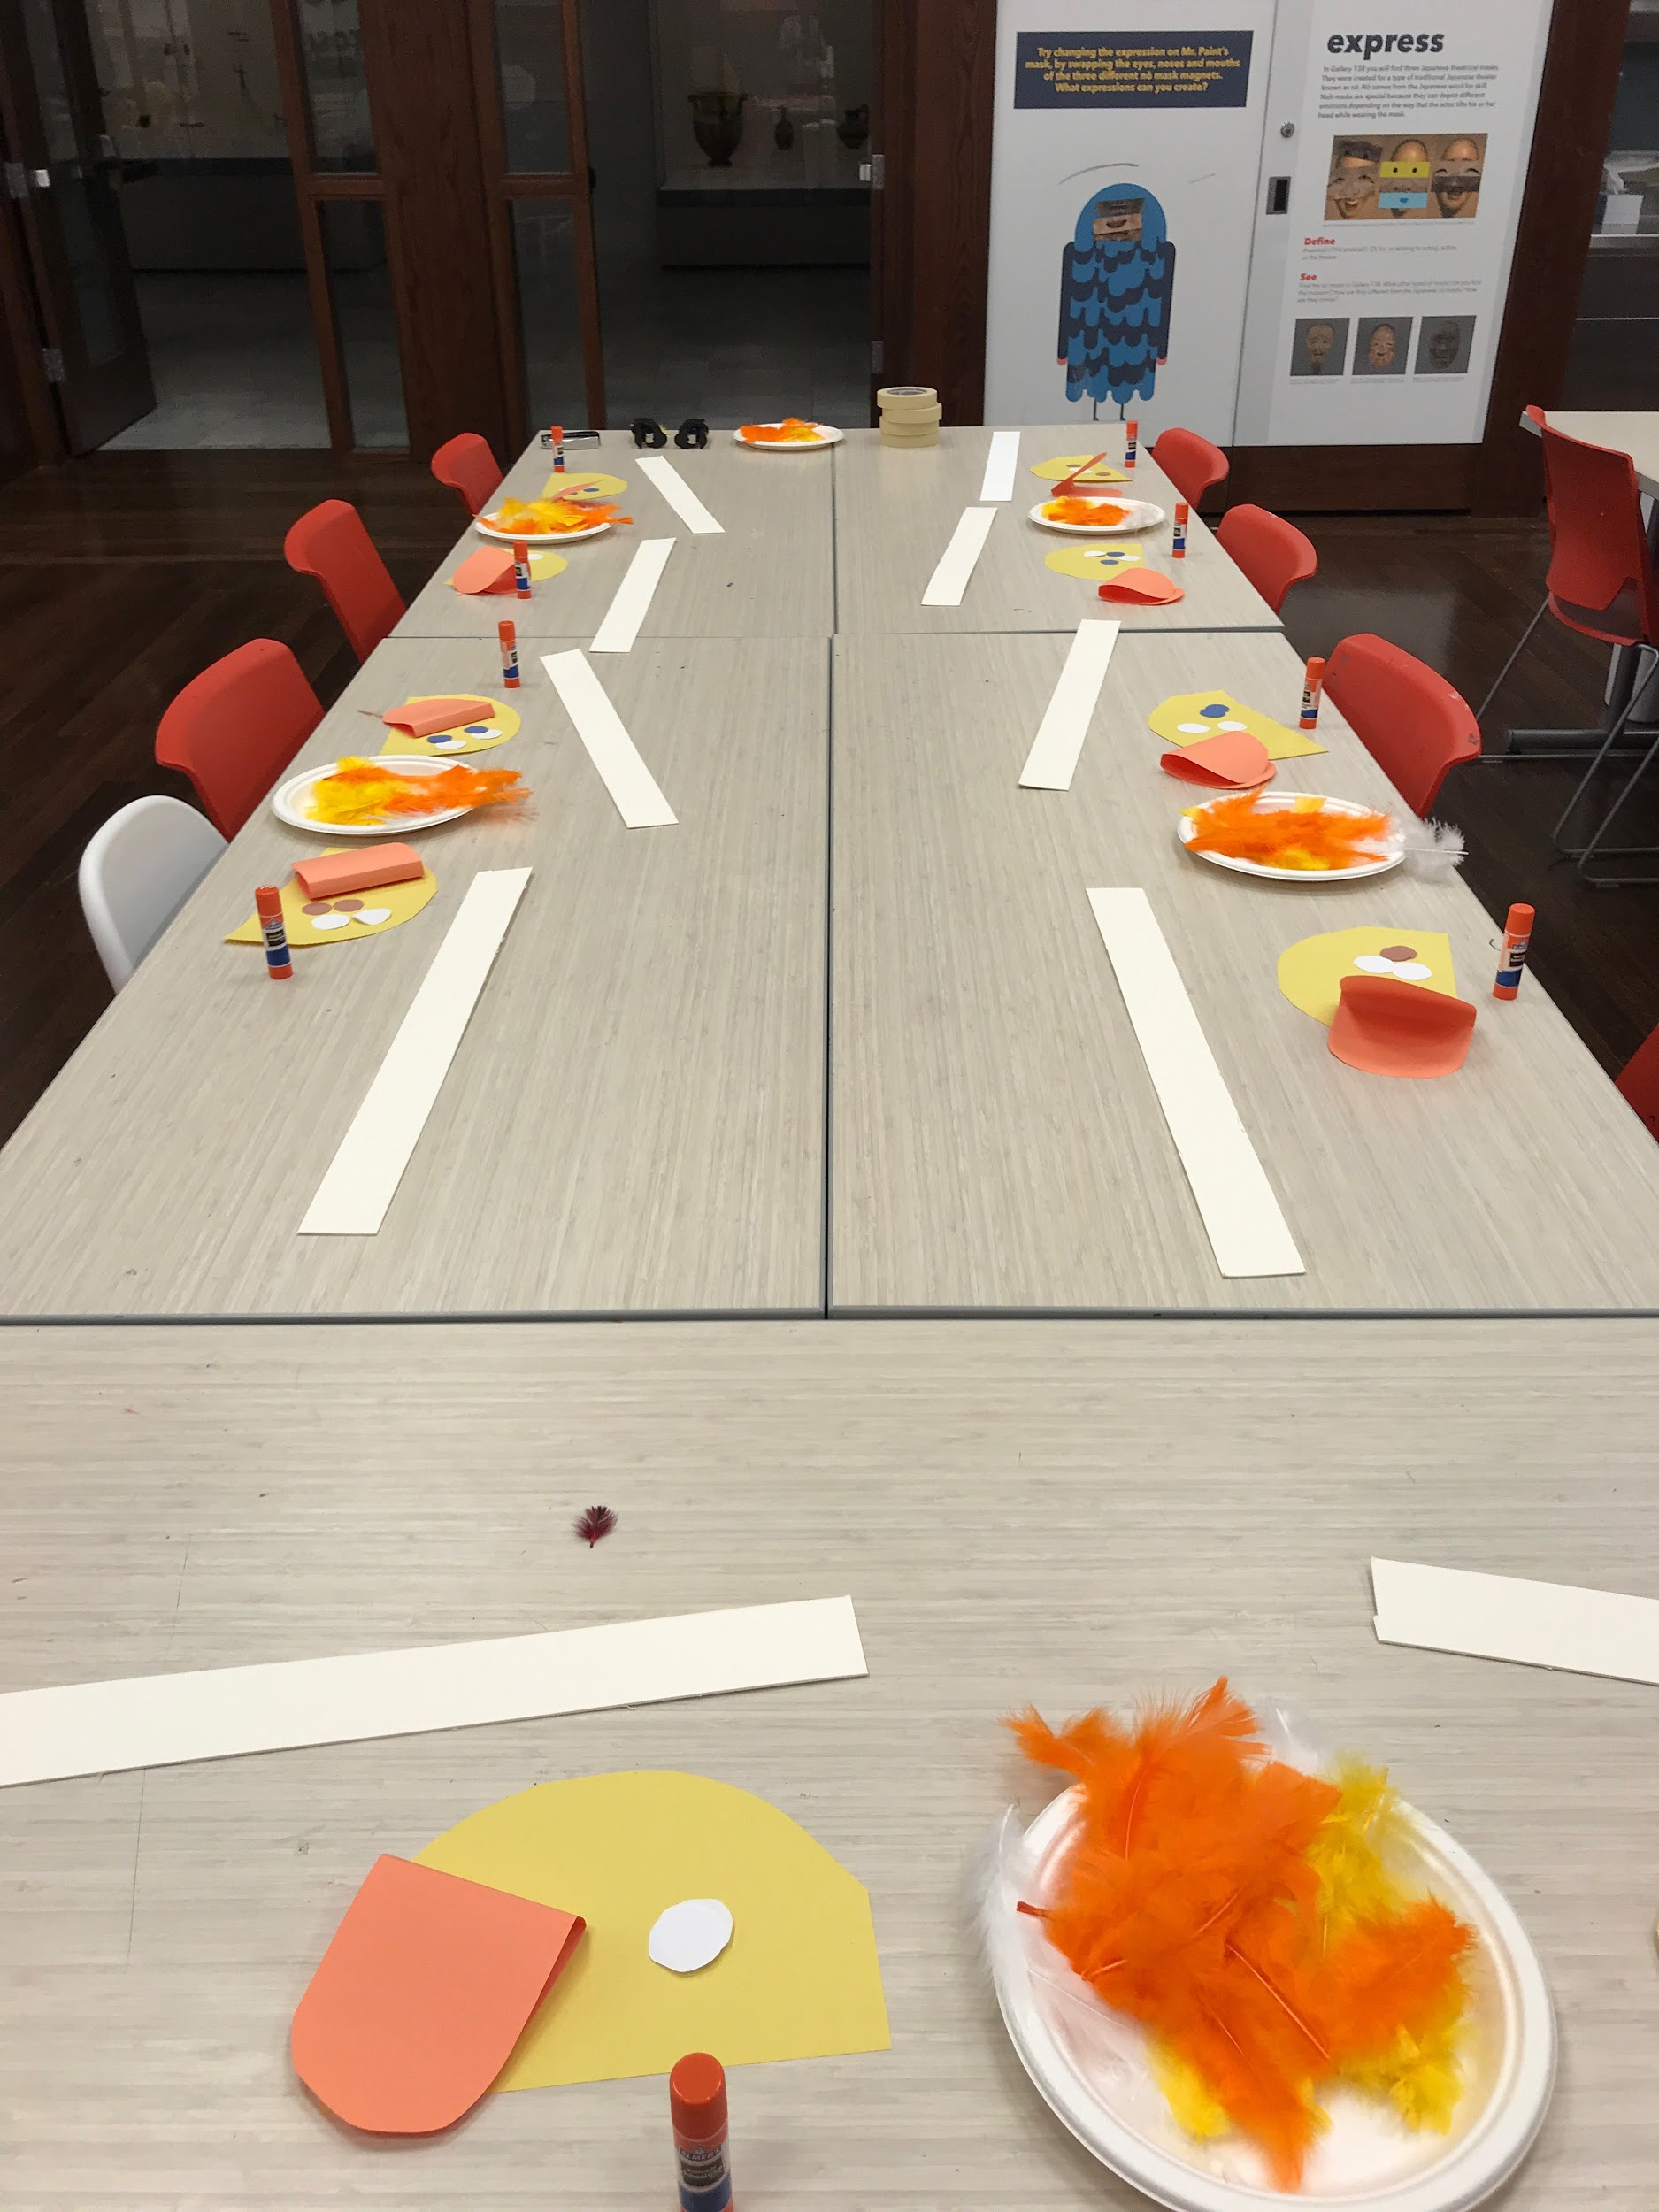

RELATED RESOURCES
Use these books to guide the lesson and add more meaning to the students’ artmaking.

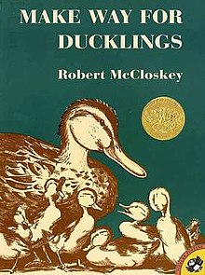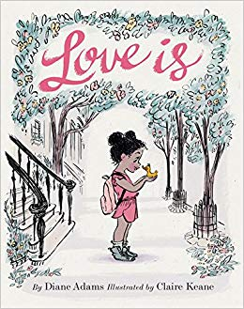
Make Way for Ducklings Love Is
Robert McCloskey Diane Adams

ADDITIONAL ACTIVITIES

Ask students:
What sound does a duck make?
What sound does a chick make?

The American Sign Language sign for Duck:

